 | 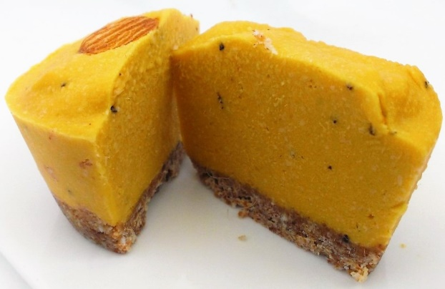 |  |  |  | Raw FRUIT / BERRY DELICE  Makes 12 Delices in silicone muffin molds  Easy to make and delicious raw dessert!  - Cane Sugar Free Dairy Free Egg Free  - Gluten Free

ingredients
BASE  Salt Pinch  Almond/Cashew Meal 100gm  Organic Desiccated Coconut 70gm  Coconut Oil 10gm  Pitted Dates 100gm | CHEESECAKE  Frozen Fruits reduced 1kg  Cashew Meal 150gm  Coconut Sugar 60gm  Coconut Oil 60gm  Salt Pinch

Fruit Reduction
Fruit Options:
Mixed Berries
Raspberries & Pistachio
Strawberries & Cacao
Mango & Passionfruit
Blueberries

method

BASE
- Combine all ingredients in the bowl. Blitz on Sp7 for approx. 20sec until the mixture is a crumble and is slightly stick. Check at 15 secs then at 5 second intervals until the texture is right.
- Distribute the mix into 12 equal measures into each of the 12 muffin molds.
- To form a firm biscuit-like base, press each measure down firmly with the base of a glass of a similar size to the base of the silicone mold.
- Set aside for the ‘cheesecake’ mixture to be added.
CHEESECAKE
- Place berries or fruit in a large saucepan and reduce on a medium heat until most of the liquid has evaporated. Stir occasionally to prevent sticking to the bottom. This will normally take 4-6 hours. Allow to cool.
- Place all ingredients including the reduction into the bowl and blitz on Sp7 for 2 minutes until well blended.
- Distribute the mixture equally into the 12 prepared molds.
- Garnish as desired
- Place in freezer. Remove from molds when frozen.

NOTES 1. The fruit reduction should be completed first. 2. The same mixture can be shaped into a slice and cut when partially frozen. 3 For a double batch – double the mix.

